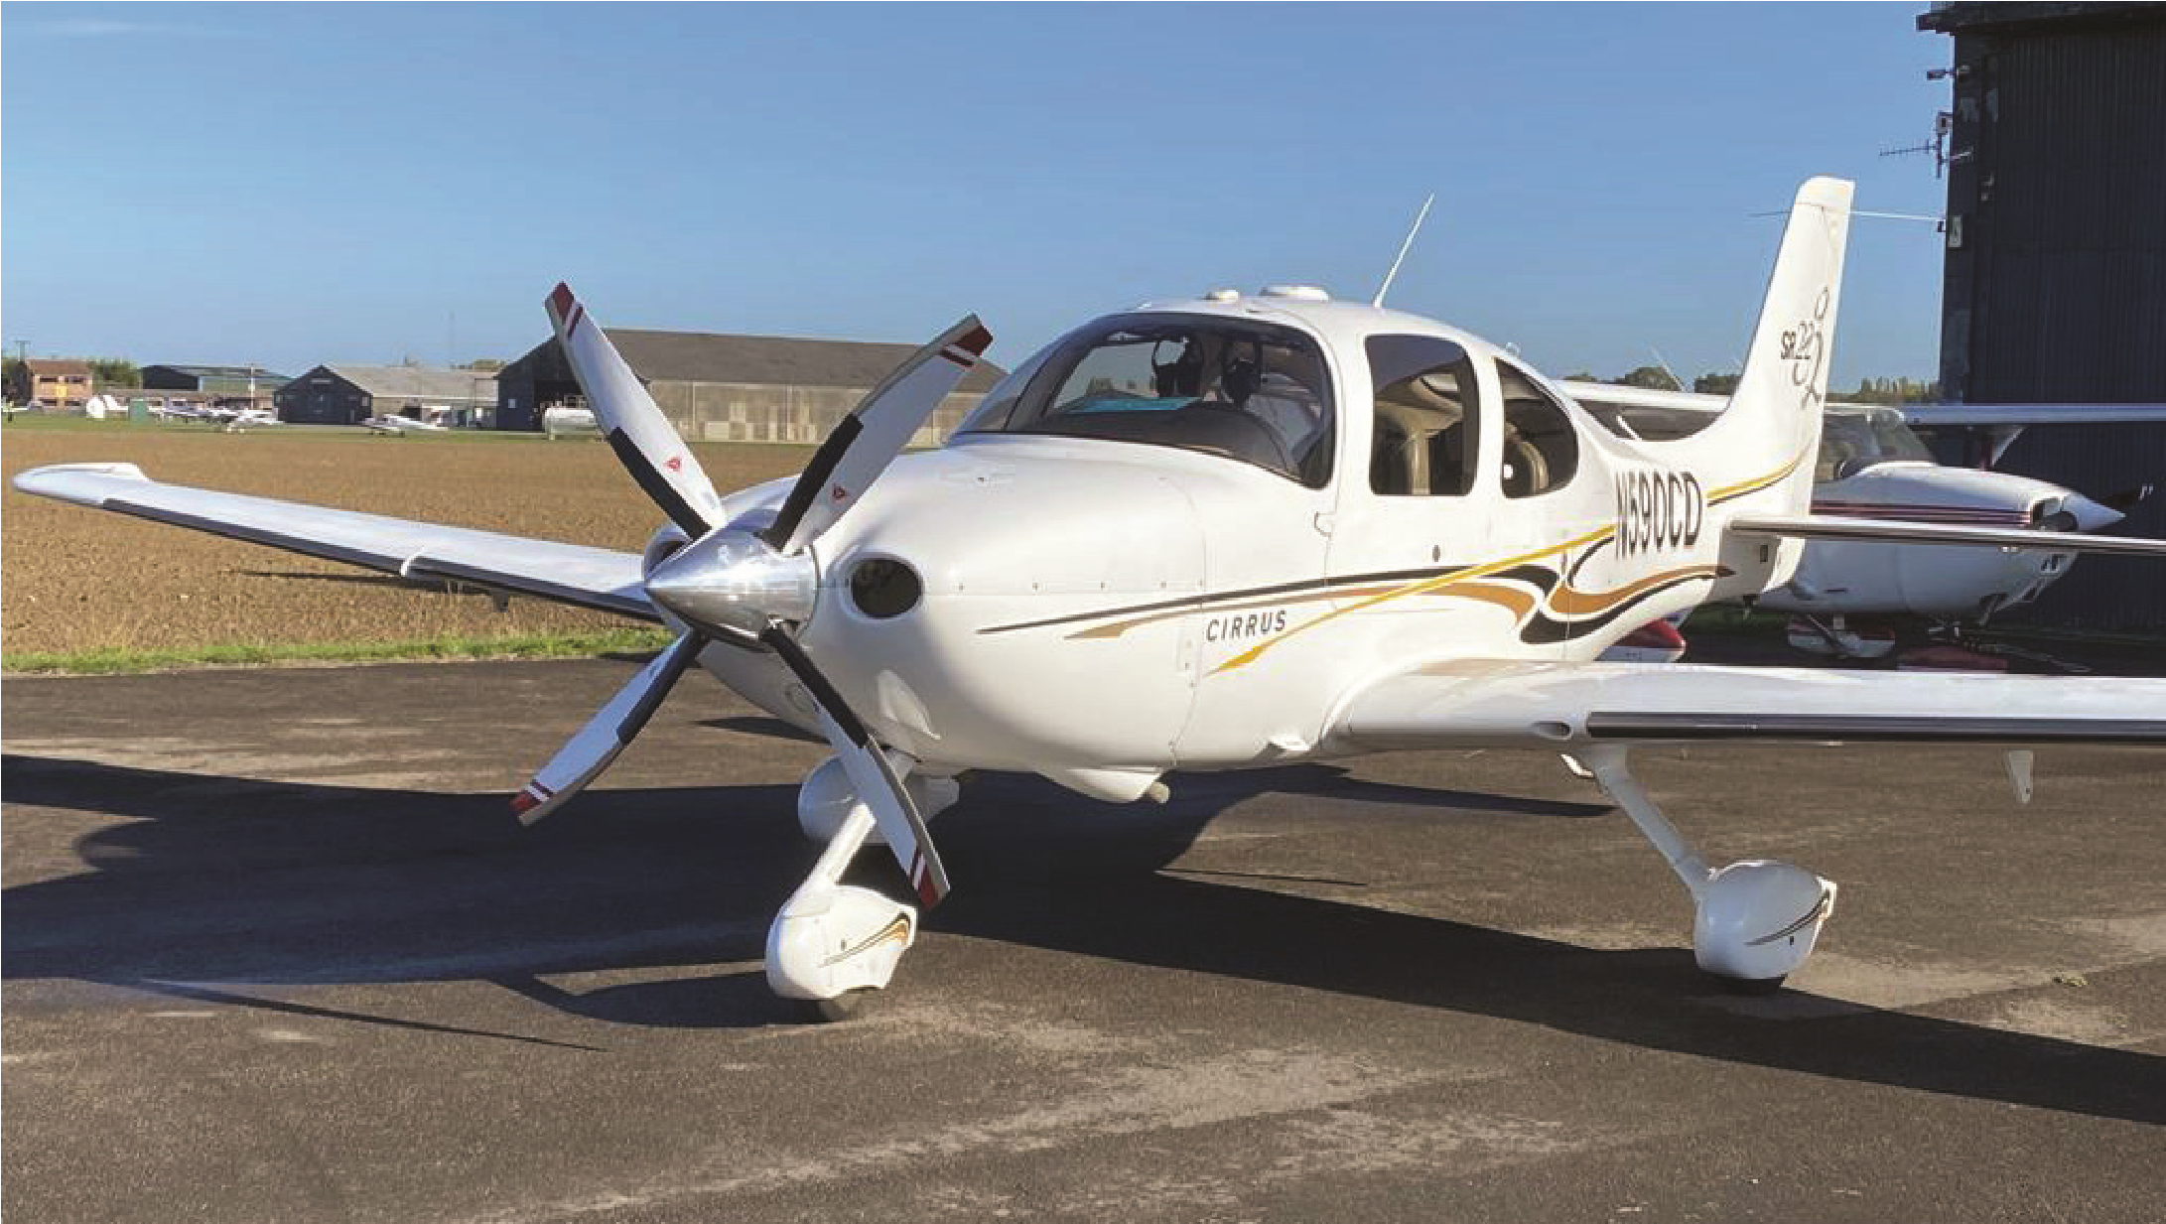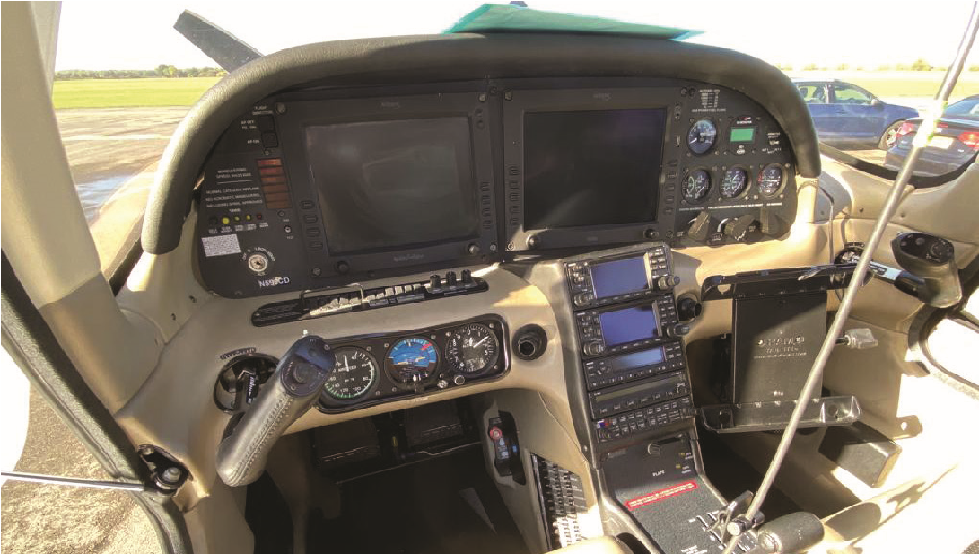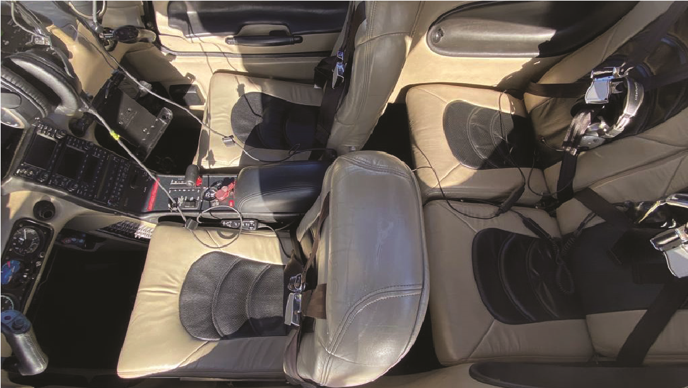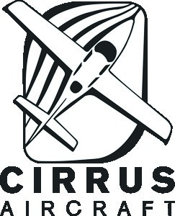

**2004**

**CIRRUS**

**SR 22 G2**

**1**

**/5 SHARE FOR SALE**

•

Aircraft is on an N-reg but is maintained at

Multiflight Leeds as a G-reg.

•

Friendly, well-run group under a limited company.

•

Internet booking system.

•

All usual avionics plus 4-blade prop.

•

Avidyne PFD & MFD with warranties.

•

2

x Garmin 430 with WAAS

•

S-Tech 55 Autopilot Linked

•

TCAS, Terrain, Storm Scope

•

De-ice system and CAPS (parachute)

•

headsets, 2 Bose A20’s

4

•

1

/5 share £

50,000

•

£200 per month standing charge

•

£65 per hour dry flying charge

A rare opportunity to have share of this

long-range SEP aircraft based at Sherburn.

Interested parties must have a

minimum of 250 hours.

PIC & PREF: Minimum IR(R)

**For further information, contact Stuart on:**

**stuart@btconnect.com**

**07879400129 | 400**