G

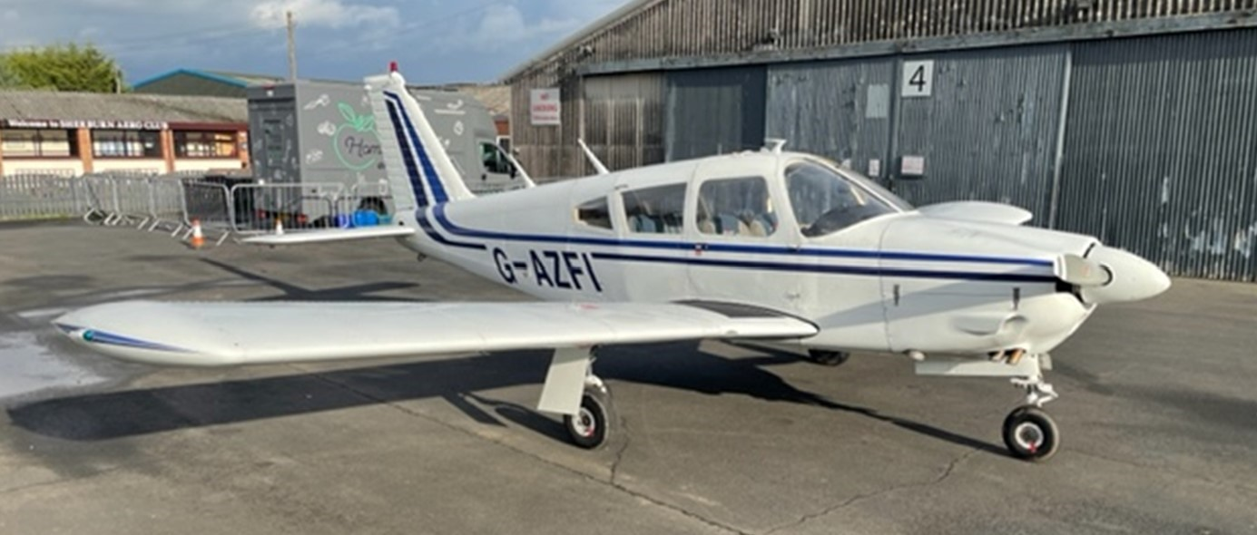

G

-

AZFI PA28R 200 ARROW II

-

/4 SHARE FOR SALE

1

A great opportunity to own a share in this well

-

equipped touring aircraft

You will be joining a friendly group which has a long history at Sherburn Aero Club

Interested parties will require a minimum of 100 hours as PIC

For Further information contact Chris Mansell on 07970 890783 or chris.mansell@hobartuk.com

**£25,000**

**£225 per month, ~£3,000 in group account, online booking with good availability**



Airframe 5,946 hours



Recent new Lycoming IO

-

360

-

CIC engine 160

hours



Hartzell 2 blade variable pitch prop 34 hours



Garmin GNS 430 (Nav/Com)



Narco 810 (Com)



Narco 141 ADF



Narco 890 DME



Garmin GTX 330 Transponder



Garmin GMA 340 Audio Panel



Piper Auto Control III Auto Pilot



SkyEcho ADS

-

B



ICOM IC

-

A25NE COM/VOR handheld transceiver

